Software Engineering Assignment

MODULE: 4 SE – OOP Concept

WAP to print “Hello World” using C++
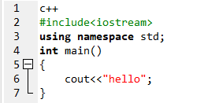

What is OOP? List OOP concepts
OOP stands for Object oriented programming. The 4 concepts of OOP are:
- Encapsulation
- Abstraction
- Inheritance
- Polymorphism

What is the difference between OOP and POP?
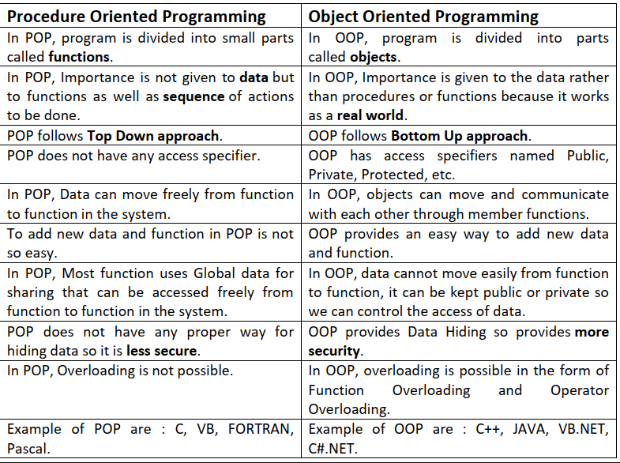

WAP to create simple calculator using class
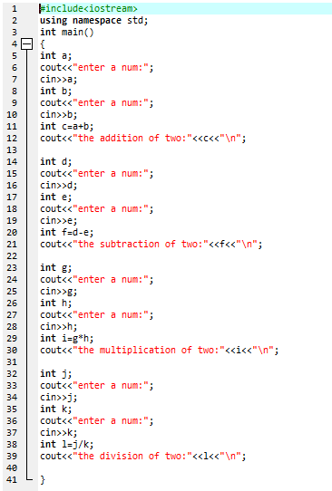

Define a class to represent a bank account. Include the following members: 1. Data Member: -Name of the depositor -Account Number -Type of Account -Balance amount in the account 2. Member Functions -To assign values -To deposited an amount -To withdraw an amount after checking balance -To display name and balance
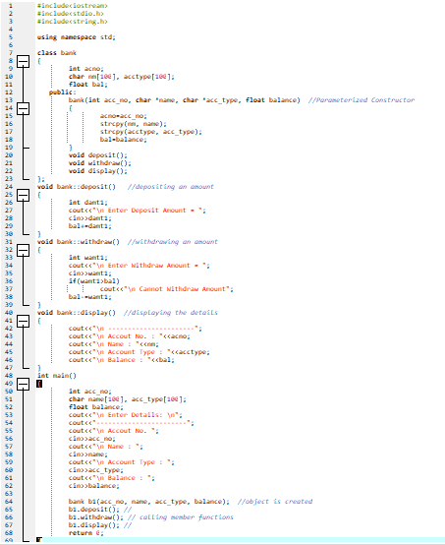
OUTPUT:
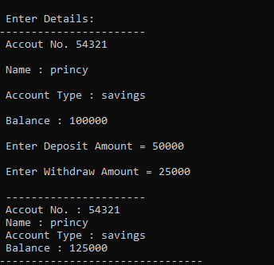

Write a program of Addition, Subtraction, Division, Multiplication using constructor.
OR
Write a program to Mathematic operation like Addition, Subtraction, Multiplication, Division Of two number using different parameters and Function Overloading
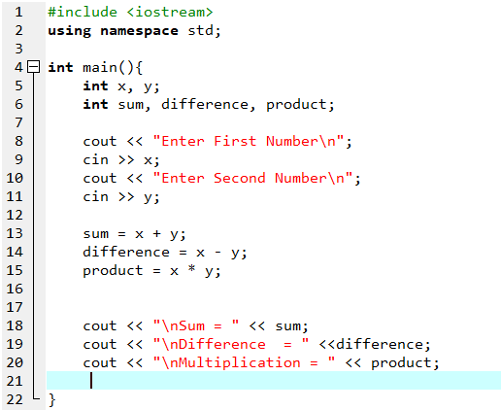
OUTPUT:
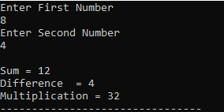

Assume a class cricketer is declared. Declare a derived class batsman from cricketer. Data member of batsman. Total runs, Average runs and best performance. Member functions input data, calculate average runs, Display data. (Single Inheritance)
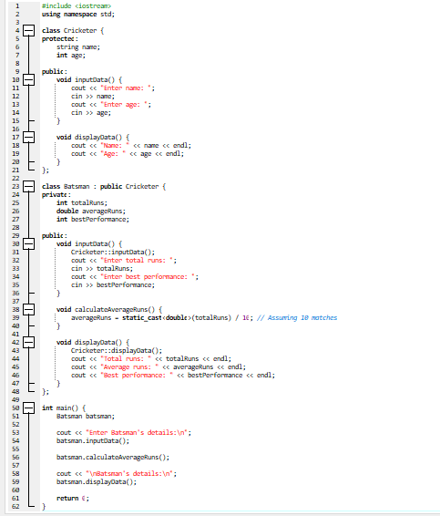
OUTPUT:
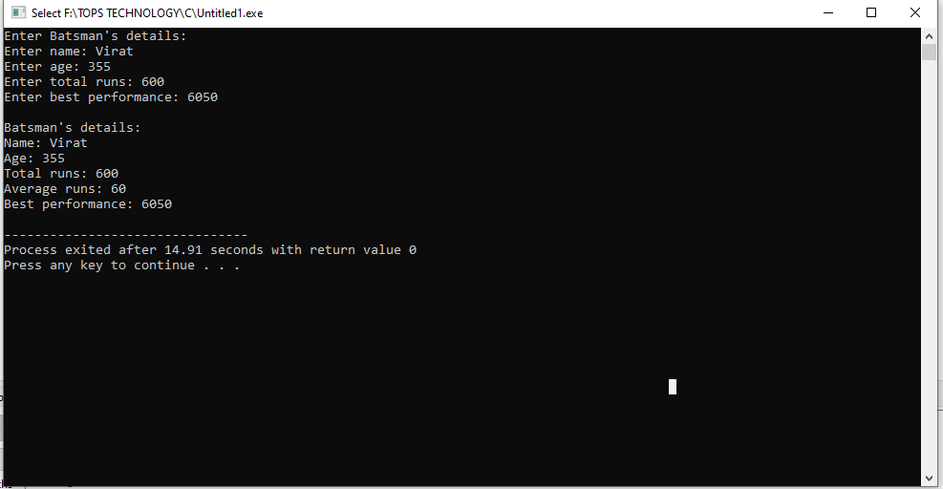

Create a class person having members name and age. Derive a class student
having member percentage. Derive another class teacher having member
salary. Write necessary member function to initialize, read and write data.
Write also Main function (Multiple Inheritance)
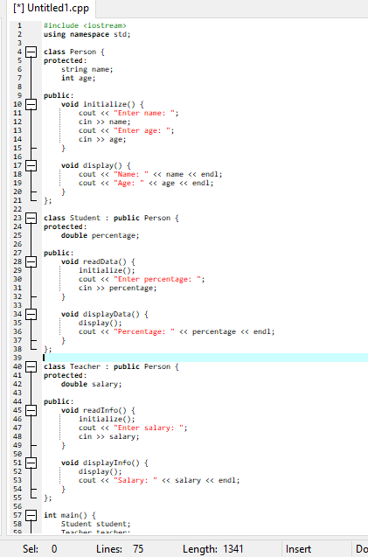
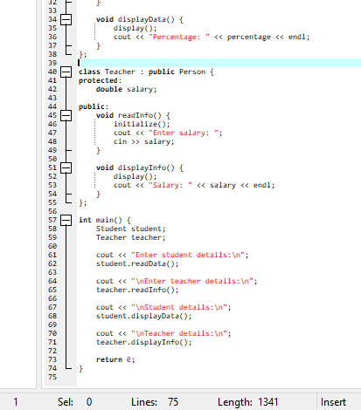
OUTPUT:
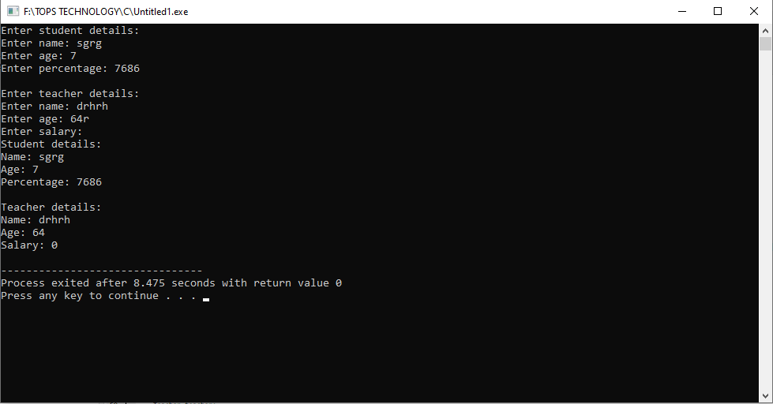
Assume that the test results of a batch of students are stored in three different
classes. Class Students are storing the roll number. Class Test stores the
marks obtained in two subjects and class result contains the total marks
obtained in the test. The class result can inherit the details of the marks obtained in the test and roll number of students. (Multilevel Inheritance)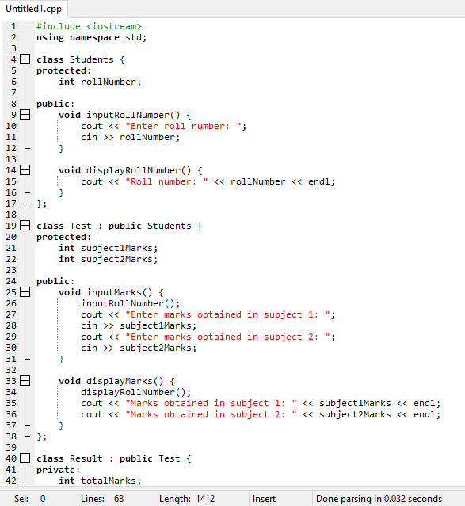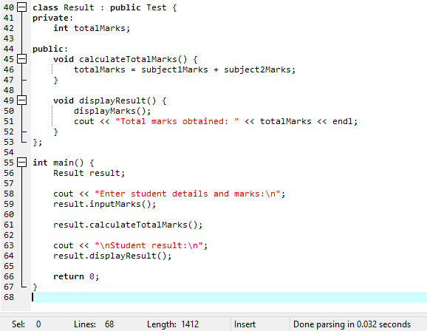

OUTPUT:
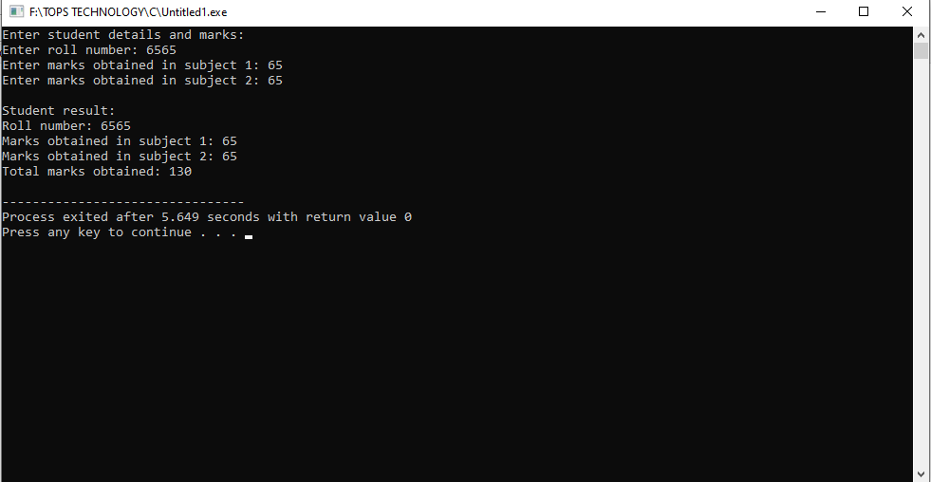
Write a Program of Two 1D Matrix Addition using Operator Overloading
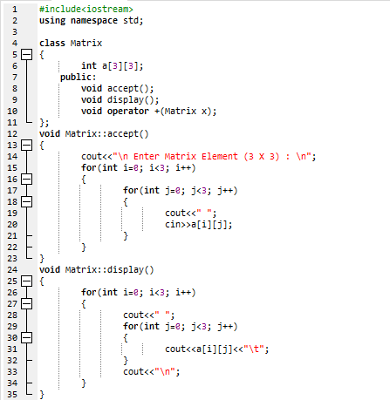
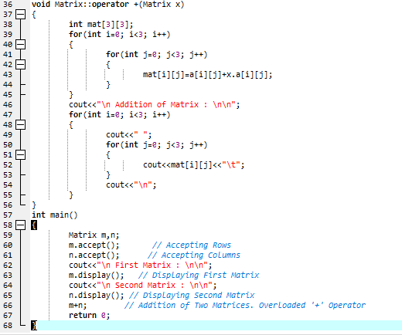
OUTPUT:
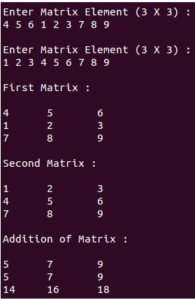

Write a program to concatenate the two strings using Operator Overloading
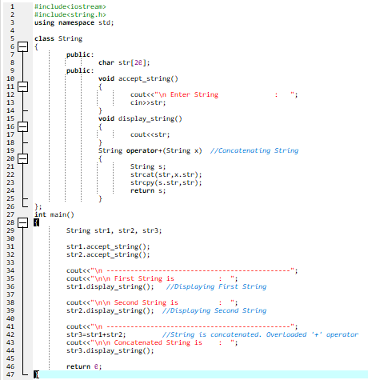
OUTPUT:
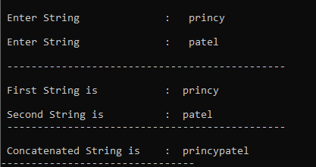

Write a program to calculate the area of circle, rectangle and triangle using Function Overloading
Circle: Pi * Area *Area
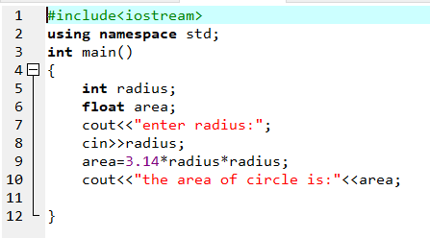
OUTPUT:
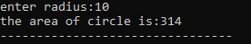

Triangle: ½ *Area* breadth
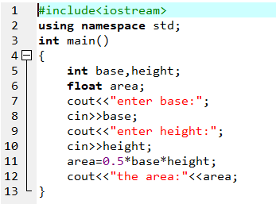
OUTPUT:
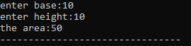

Rectangle: Area * breadth
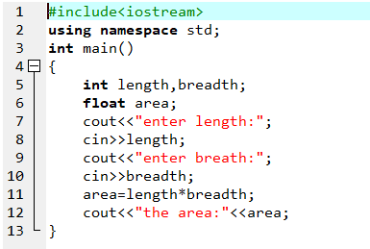
OUTPUT:
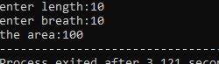

Write a program to swap the two numbers using friend function without using third variable
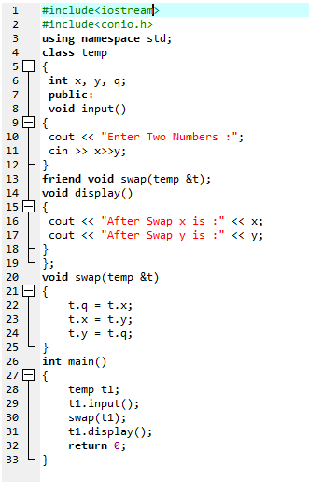
Output:
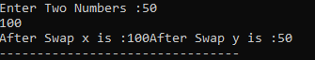

Write a program to find the max number from given two numbers using friend function
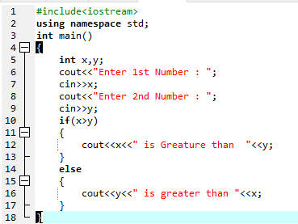
OUTPUT:
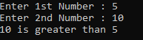

Write a program of to swap the two values using templates
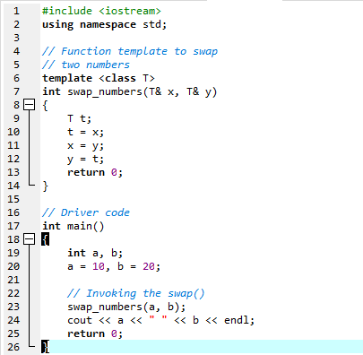
OUTPUT:
